**Joint Minnesota Area 35 & Area 36 Statewide Corrections Committee**

**CORRECTIONS WORKSHOP**

November 2, 2024

9:30 AM to 3:00 PM

Jack & Jim’s Event Center

11025 Duelm Road NE, Foley, MN 56329

(15 miles Northeast of St Cloud, MN)

IN PERSON AND ONLINE!

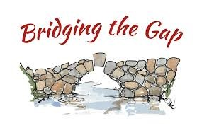

**Carl D, A.A. Corrections Speaker, Castle Rock, CO**

**Jesse Pugh, Warden, MCF-St Cloud Prison**

**Craig H, A.A. CTCP Presentation, Area 36 Corrections Chair**

**Question & Answer Session**

(Step to the Mic, raise your hand online, ask our Guests anything about today’s topics!)

**Online Registration**

Go to: [2024 SWCC Corrections Workshop registration](https://events.teams.microsoft.com/event/dc097fe5-c746-4af9-82d7-a50007a9da5b@c9589300-d348-46b9-9e64-e5fec693cbfa) (Press CTRL plus CLICK to follow the Link)

for workshop information/registration or use the QR Code below. Once registered,

you will be provided with a meeting link for access the day of the event.

Contents of the workshop folders and forms will also be provided at this link or QR code.

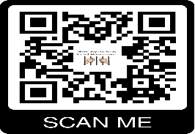

**Sandwich, Soup, and Salad Buffet Lunch for only $16.50**

**FREE Coffee ALL DAY!**

**For more information, please contact:**

Mark R. [corrections@area35.org](mailto:corrections@area35.org) / [correctionsmn@gmail.com](mailto:correctionsmn@gmail.com) or Craig H, [corrections@area36.org](mailto:corrections@area36.org)